EECE 340 Project Module 1 Report

Abdullatif Itani 202203750

Charbel Toumieh 202218744

* 1. Fourier Series Implementation:

The function "ffs" is an implementation of the Fourier Series, which aims to compute the Fourier coefficients and reconstruct the signal using a Fourier Series representation. The user needs to provide four inputs, including "xt" which is the continuous-time signal to be represented, "t" which is the time interval where the signal is defined, "n" which is the number of iterations of the wave to be included in the Fourier Series, and "T" which is the fundamental period of the signal.

The function returns two outputs, "xhat" which represents the reconstructed signal using a Fourier Series representation, and "ck" which is a vector containing the Fourier coefficients for the iterations of the wave. Finally, the function returns the ck and xhat vectors as outputs.

The function begins by initializing the ck and xhat vectors to zero. It then iterates from -n to n in a loop, computing the Fourier coefficients, and stores them in the ck vector. The function then uses the calculated Fourier coefficients to reconstruct the signal xhat. Finally, the function returns the ck and xhat vectors as outputs.

* 1. Changing n:

This code aims to demonstrate the impact of changing the number of iterations of the wave on the accuracy of a Fourier Series approximation for a given signal. We first load the data for the signal and define the fundamental period and a range of n values to use in the approximation.

Then, the ffs function is applied to calculate the Fourier coefficients and approximate the signal using a Fourier Series representation for each value of n. These approximations are stored as xhat.

We then plot the original signal and its approximations for different n values, demonstrating how the accuracy of the approximation improves with increasing number of wave iterations. The error between the original signal and its approximations is also calculated using numerical integration and plotted as a function of n, showing that the error decreases as more wave iterations are included in the approximation.

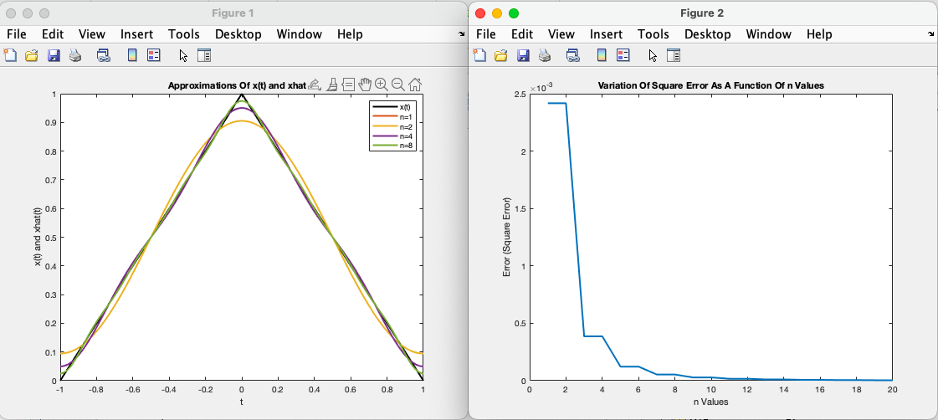

* 1. Changing T:

This code aims to demonstrate how altering the fundamental period of a periodic signal affects the accuracy of its Fourier Series approximation.

We first load the data and plot the signal to examine its contents. Next, we find the smallest number of wave iterations required to accurately represent the signal. Then we define a range of T values to use for approximations and calculates the error between the original signal and its Fourier Series approximation for each T value. Finally, the errors are plotted as a function of T to demonstrate the effect of changing the fundamental period on the accuracy of the approximation.

The results show that the error is minimized when T is a multiple of the signal's period(2), indicating that a smaller number of wave iterations can be used to accurately represent the signal.

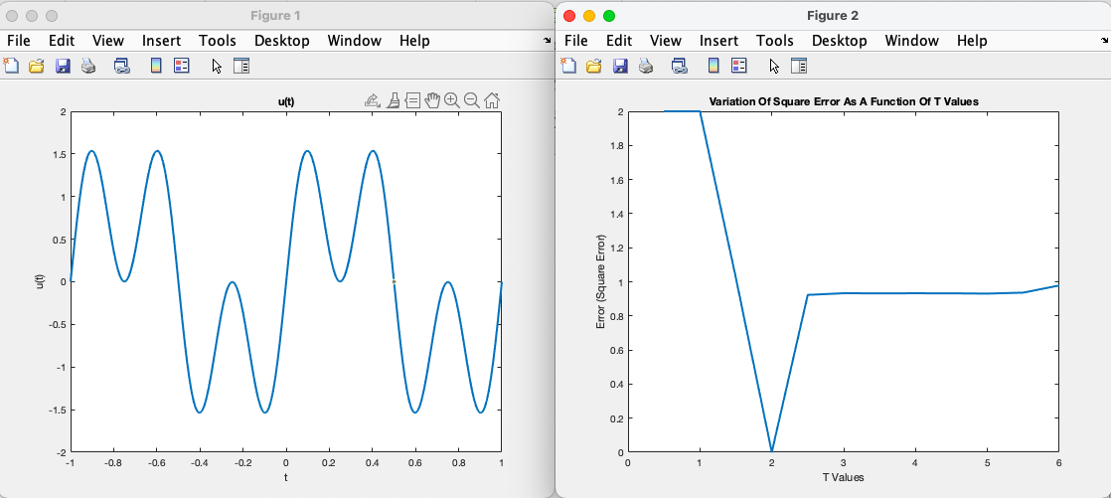

What is the smallest value of T for which the square error is zero?

The smallest value of T for which the square error is zero is T=2.

For n = ∞, how many coefficients satisfy ck ̸= 0? Explain why.

All coefficients in the Fourier series of u(t) have non-zero values when goes to infinity. The Fourier series converges slowly as a result of the sharp discontinuities in u(t) at t = |1|. Since the slow convergence prevents the Fourier coefficients from decaying to zero as n rises, all the coefficients help to approximate u(t). However, the higher frequency components have less of an effect on the signals overall structure because the coefficients amplitudes decline with frequency.